Template for Submissions to ICBEM 2018
to be published in the proceedings
H.G. Testauthor¹, J.J. Testtwo¹, S.L. Threetest^{1,2}
¹Organization 1, Samplestr. 12, Aachen, Germany
²Organization 2, Default Avenue 1a, Bonn, Germany
Contact: Testauthor@test.de

Introduction
The 11th International Conference on Bioelectromagnetism (ICBEM) will be held jointly with the 13th Russian-German Conference on Biomedical Engineering (RGC) in Aachen, Germany, on 23 ‑ 25th May 2018 under the auspices of the International Society for Bioelectromagnetism (ISBEM). Since its beginnings in Tampere, Finland in 1996, the conference took place in Melbourne (1998), Bled (2000), Montreal (2002), Minneapolis (2005), Aizu (2007), Rome (2009), Banff (2011), Geneva (2013) and Tallinn (2015).

In 2018, the conference will be hosted by the Philips Chair for Medical Information Technology (MedIT) at RWTH Aachen University. Following the fundamental idea of the ISBEM, the ICBEM & RGC 2018 provides a platform for researchers all over the world to share their experience regarding their work in the broad field of bioelectromagnetism.

All contributions to the 11th ICBEM International Conference on Bioelectromagnetism at RWTH Aachen University will be published in a conference proceedings with ISBN-number, will be made available as a supplement to the International Journal of Bioelectromagnetism (www.ijbem.org) and will be made available online with DOI on the publication server of RWTH Aachen University.
In order to achieve uniform appearance, please use the template provided. We accept contributions only in PDF Format, compliant with PDF X/3 standard. All fonts need to be included and no password protection set. The resolution of images should be at least 200 dpi.
Materials and Methods
The official language of the conference is English.

Text and Pages
Format: The page format is A4. The type area must be centered and have a width of 17 cm and a height of 24 cm. There must not be any page numbers on the pages. The edge must be 25 mm above and below and 20 mm left and right. Arrange the text in two columns, each 82.5 mm wide, with a 5 mm gap between the columns.
Fonts: Use TIMES NEW ROMAN font. Excluded are the title of the contribution and the headings for which the font ARIAL is used. Font sizes are given in tab. 1.
Title and Authors: The title should not be longer than two lines. Arrange titles, author names, institute names and contact addresses centered.
Length: A maximum of four DIN A4 pages are provided for each contribution. Texts longer than four pages cannot be published.
Abstract: An abstract is not included.

Table 1: Font Sizes
Object | Font Size | Type
Title | 14 | Bold
Author names and affiliations | 10 | Standard
Section headline | 12 | Bold
Subsection headline | 10 | Standard
Text | 10 | Standard
Literature | 9 | See examples

Figures and Tables
Please refer to figures and tables in the text, e. g. see fig. 1 or tab. 1. Figures and tables should be incorporated into the text. You will find examples in this text. If necessary, figures and tables may also extend over the width of an entire page. Label illustrations and tables as follows: figures receive a signature, tables a headline. Headline and signature are to be centered.

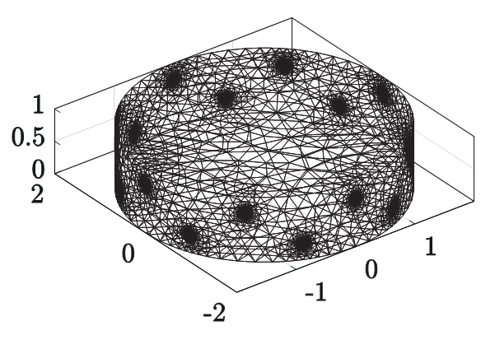
Figure 1: Example Figure

Equations and Literature
Equations: Use numbers in parentheses to the right of the equations.
 | $$I=\iint_{Σ}{J ∙dS}$$ | ( 1 )

Literature: Bibliographical references are to be identified by numbers in square brackets. The bibliographical references should be summarised at the end of the manuscript and should not be presented individually as footnotes. As an example this text refers to two books [1, 2], a contribution in a book [3], two journal articles [4, 5], a conference contribution [6] and a thesis [7]. The numbering of bibliographical references is based on the order in which they appear in the article text.

Results
Figure. 1 shows an example of a figure. Do not use characters with smaller type sizes than 8pt in illustrations and tables. If possible avoid using color illustrations.

Copyright
For publication of your abstract the conference organisers require a simple, non exclusive transfer of copyright of your work. All other rights remain with the authors. You are free to use the material elsewhere. You can even assign a creative commons license to your work.
In submitting an article to the conference, the authors agree on the following legal terms:

Granting of Rights by the Author and Duties of the Author
(1) The author grants the Conference Organisers the non-exclusive right to make available, disseminate, copy and electronically store on its servers the above named work, including the provided bibliographic information, for an unlimited period of time and free of royalties. If the author has written and included an abstract of the work, the above granted rights extend to the abstract. Intellectual property rights and rights for the exploitation of the work are not affected by the present agreement.
(2) The author is responsible for the content of the work.
(3) The author warrants that making available the work, including all of its parts, such as illustrations and figures, does not constitute a breach of laws and does not violate the rights of third parties (such as publishing houses). The author confirms to indemnify the Conference Organisers from possible claims by third parties.
3.1 In the case of multi-authorship, the signing author declares to act on behalf of and in accordance with all other co-authors.
3.2 If the work has already been published (e.g. by a publishing house), the author confirms that publishing the work using the RWTH publication repository as well as the IJBEM does not breach the contract with the original publisher.
(4) The author agrees to immediately notify the Conference Organisers if there are any prospective or actual legal obstacles that pose a problem to fulfilling the present agreement or cast doubts on its fulfillment.
(5) The author agrees to the bibliographical data being extended and modified by the Conference Organisers in accordance with international standards.
(6) The author grants the Conference Organisers the right to technically modify the work, if necessary, e.g. for the purposes of long-term storage or better and broader accessibility. This includes conversion of the work into other electronic and physical formats, in accordance with (1).
(7) The author grants the Conference Organisers the right to make the provided bibliographical data available to other databases free of charge. Moreover, he or she grants the Conference Organisers the right to make the work available as part of national aggregate orders or for the purpose of preservation (as a rule through the German National Library and DFG special collections), as long as there are no agreements to the contrary with third parties, e.g. publishers, that pose obstacles to such proceedings.

Discussion
When compiling your contribution, please consider the structure according to the scheme shown here. Of course, individual headlines can be omitted or added.

Conclusions
We hope that the explanations given above are clear and understandable, so that there is no need for discussion here. If you have any questions or problems, please do not hesitate to contact us by e-mail at icbem2018@hia.rwth-aachen.de.

References
[1] K.J. Åström and B. Wittenmark. Computer-Controlled Systems: Theory and Design. Prentice-Hall, Inc., 1997.
[2] Jaakko Malmivuo and Robert Plonsey. Bioelectromagnetism: Principles and Applications of Bioelectric and Biomagnetic Fields. Oxford Univ Press, 1995.
[3] S. Leonhardt. Physikalisch-technische Grundlagen. In S. Leonhardt and M. Walter, editors, Medizintechnische Systeme, pages 5–38. Springer Verlag Berlin-HeidelbergNew York, 2015.
[4] C. J. De Luca. The use of surface electromyography in biomechanics. J Appl Biomech, 13(2):135–163, 1997.
[5] Christoph Hoog Antink, Steffen Leonhardt, and Marian Walter. Reducing false alarms in the icu by quantifying selfsimilarity of multimodal biosignals. Physiological Measurement, 37(8):1233, 2016.
[6] Leonie Korn, Daniel Rüschen, Steffen Leonhardt, and Marian Walter. Simulation of the vectorcardiogram using a simple volume conductor model. In EMBEC & NBC 2017, pages 85–88. Springer Singapore, jun 2017.
[7] H. Test. Using bio-impedance. Master thesis, University of Technology, 2007.

Acknowledgements
Any acknowledgements may appear here.

